SOUTHAM & HARBURY BOUNCY CASTLES
www.southambouncycastle.co.uk TEL: 01926 815467
We are pleased to be supplying you with one of our Supersumo sets, please find enclosed your copy of the hire agreement printed below. (You will sign the original personalised copy at the time of your hire, that document will be retained by ourselves). If you wish to cancel your hire because you do not agree with any of our terms, please contact us immediately, and we will cancel your booking for you as units unfortunately cannot be hired out without your acceptance of our terms.
TERMS AND CONDITIONS OF HIRE. (The word UNIT in terms & conditions means any Supersumo suit Adult or Junior.)
These are the terms and conditions of hire of Southam Bouncy Castles. Please read these carefully. The company accept no responsibility for damage or injury whilst our equipment is under hire to you. Please ensure the delivery driver has free and easy access to deliver the unit and situate in a safe, clean & dry place. Please be advised that if we arrive and there is insufficient space or the area for use is unsuitable (e.g. sloping or is unclean) full payment still has to be made. Finally, due to us having received several cheques returned unpaid we require "CASH PAYMENT ONLY" on all hires upon delivery please. Southam Bouncy Castles reserve the right to cancel any booking at any time.
- Any damage will have to be paid for by the hirer named in our agreement. The driver is to be paid upon delivery of the unit, deposits are non-refundable. Late cancellations are to be charged at the rate of 50%. No signs are to be glued/taped or hung on the units at all.
- You ("the Hirer") are responsible for injury or damage occurring whilst the equipment is on hire and you are strongly advised to take out Public Liability insurance covering the use of the Units whilst it is on hire to you.
- The units cannot be left unattended, and if hired overnight, the units along with all accessories are to be stored indoors. The Hirer is responsible for safe keeping of the Units and you will be charged for any damage caused to them or for any items missing from it on its return.
- The Supersumo set is designed to be used on flat surfaces with at least 2 metres clearance. The preferred surface is grass rather than harder tarmac or concrete. Ideally a roped off area is marked out, but avoid using poles that lean inwards or are too small or pointed.
- Please ensure that the mats are connected.
- The helmets have extra padding at the rear to help protect the crown, both the suits and helmets benefit from Velcro openings inside to allow padding adjustment.
- All players are to ensure that the game is played on the mat, and is restricted to knocking or pushing each other onto or outside the circle. NO BACK FLIPS!!
- THE RULES ARE – Players are to knock opponents out of the circle. A preferred variation of this rule is to get players to knock each other down within the circle to avoid overspills, (this is particularly advisable on harder surfaces). The game is usually played as the best of three.
- THE FUN BIT – “Blobby, Blobby, Blobby” or “Bonsai” is often shouted as the players are made to repeat sumo poses such as bowing, shifting from one leg to the other or throwing pretend salt over their shoulders!!!
- Participants must be suitably fit and free of injury to play. If participants are too rowdy do not let them play!
- Food, any type of drink, cigarettes, illegal substances and pets are forbidden on all units.
- Equipment returned in a dirty condition will be subject to a cleaning charge.
- All units are checked on delivery and your signing indicated acceptance of the Unit as being in good, clean condition.
- Only our delivery driver is authorised to collect the Unit and under no circumstances should any of the equipment be handed over to anyone other than our delivery driver.
Downloadable Party Invites Available:
DATE OF HIRE:___________________________ User Name: sbcfun
Password: enjoy
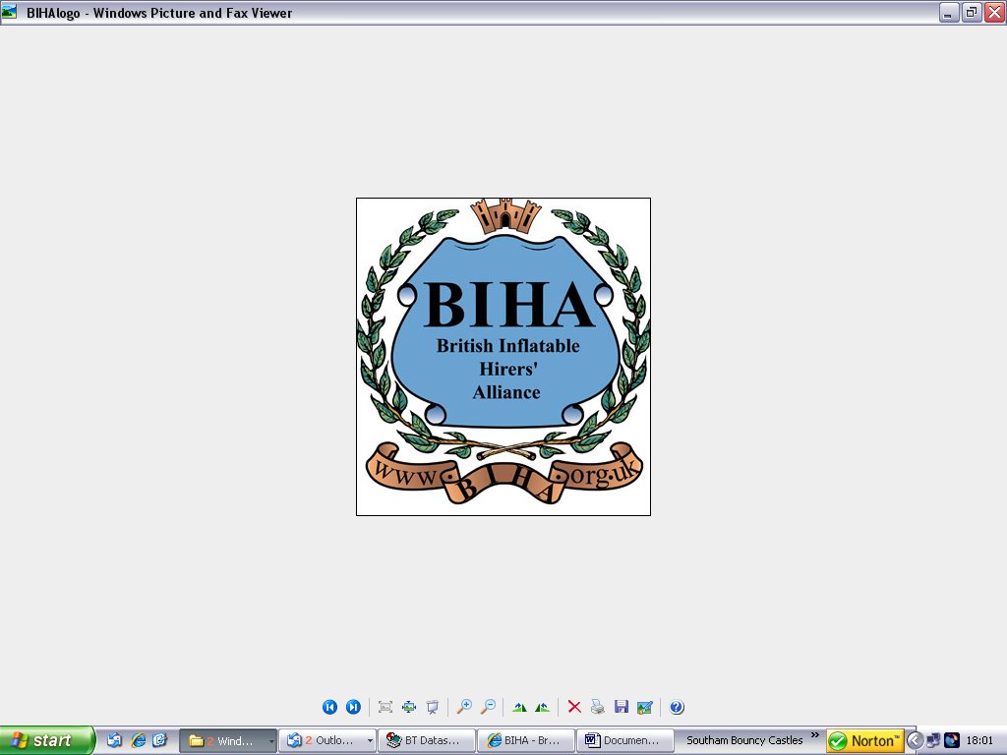

COST OF HIRE:___________________________
*Please note that payment must be made in Cash only please
ADDRESS/VENUE:_________________________

TIMES OF HIRE:__________ to ______________
*Times stated are approximate and cannot be guaranteed.

